Below you will find a chart I put in my student’s folders that are having great difficulty with story problems. This reminds them what they need to look for and some strategies to help them come up with an answer.

Key Words To Look For in Story Problems

Each → X More than → - Left → -

Difference → - Altogether → +

In all → + Total → +

Some Problem Solving Strategies



Brainstorm Make a list

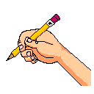



Guess and check Draw a picture


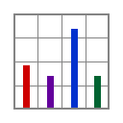

Work Backwards Make a table




Use Objects Find a pattern

